A

Minor Project-I Report

On

**“HOMEX REAL ESTATE”**

Submitted in partial fulfillment of

The requirements for the 5th Semester Sessional Examination of

BACHELOR OF TECHNOLOGY

IN

**COMPUTER SCIENCE & ENGINEERING**

By

**AMARNATH PANDA**

**SANCHITA SABAT**

**CHANDAN DANDIA**

**Registration No.**

**21UG010149**

**21UG010568**

**21UG010264**

**Under the able Supervision of**

**Dr. AVS PAWAN KUMAR**

**DEPARTMENT OF COMPUTER SCIENCE & ENGINEERING**



GIET UNIVERSITY, GUNUPUR

** 2023-24**

**GIET UNIVERSITY,GUNUPUR**

***Dist. Rayagada, Odisha765022,* *Contact: +91 7735745535, 06857250170,172, Visit us:* www.giet.edu**

**Department of Computer Science & Engineering**



**CERTIFICATE**

**This is to certify that the project work entitled “HOMEX REAL ESTATE” is done by Name - AMARNATH PANDA , SANCHITA SABAT, CHANDAN DANDIA**

**Regd. No.- 21UG010149,21UG010568,21UG010264 in partial fulfillment of the requirements for the 5th Semester Sessional Examination of Bachelor of Technology in Computer Science and Engineering during the academic year 202324. This work is submitted to the department as a part of evaluation of 5th Semester Minor ProjectI.**

Project SupervIsor Class Teacher

Dr. AVS Pawan Kumar Miss.Pranita Mahapatro

Project Coordinator, 3rd Year HoD,CSE

Mr.Bhavani Sankar Panda Dr.Kakita Murali Gopaal

**ACKNOWLEDGEMENT**

We express our sincere gratitude to Prof. (Dr). AVS PAWAN KUMAR of Computer science and engineering for giving us an opportunity to accomplish the project. Without his/her active support and guidance, this project report has not been successfully completed.

We also thank Mr.Bhavani Sankar Panda, Project Coordinator, Dr. Kakita Murali Gopal, Head of the Department of Computer Science and Engineering, Prof. (Dr.) Sanjay Kumar Kuanar, Dy. Dean, Computational Science, SOET for their consistent support, guidance and help.

Amarnath panda (21UG010149)

Sanchita Sabat (21UG010568)

Chandan Dandia(21UG010264)

**DATABASES**

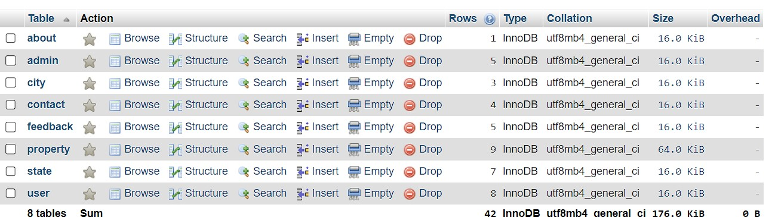

**ADMIN DATABSE**

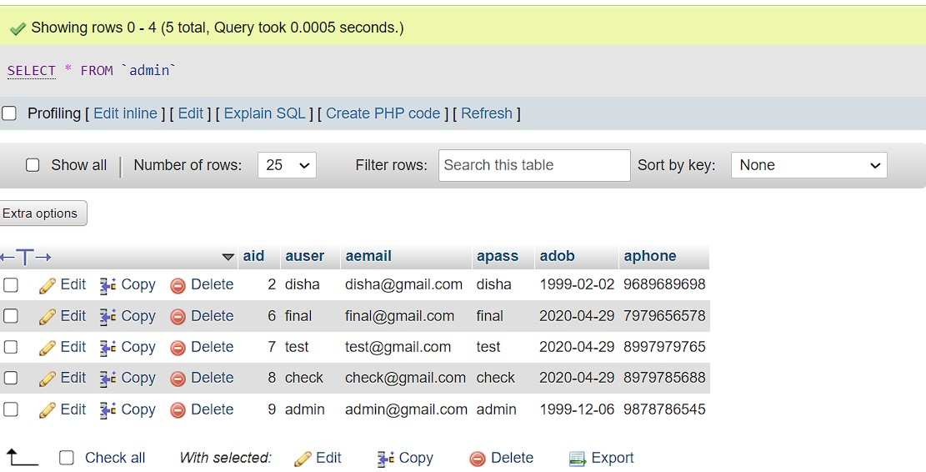

**CITY DATABASES**  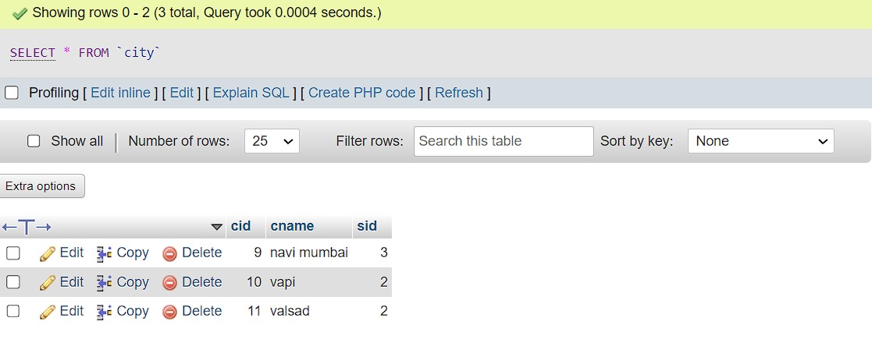

**CONTACT DATABASES**

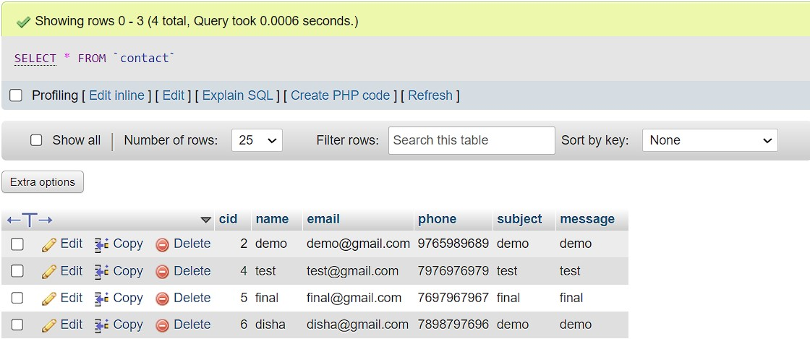

**FEEDBACK DATABASES**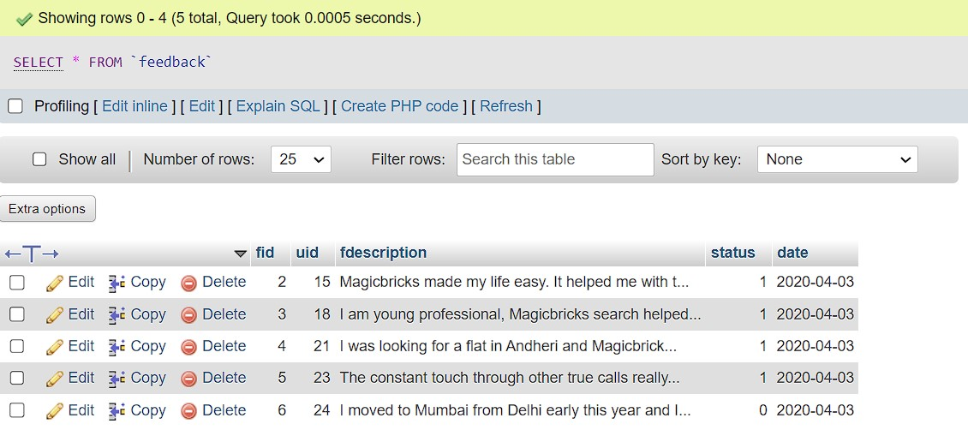

**PROPERTY DATABASE**

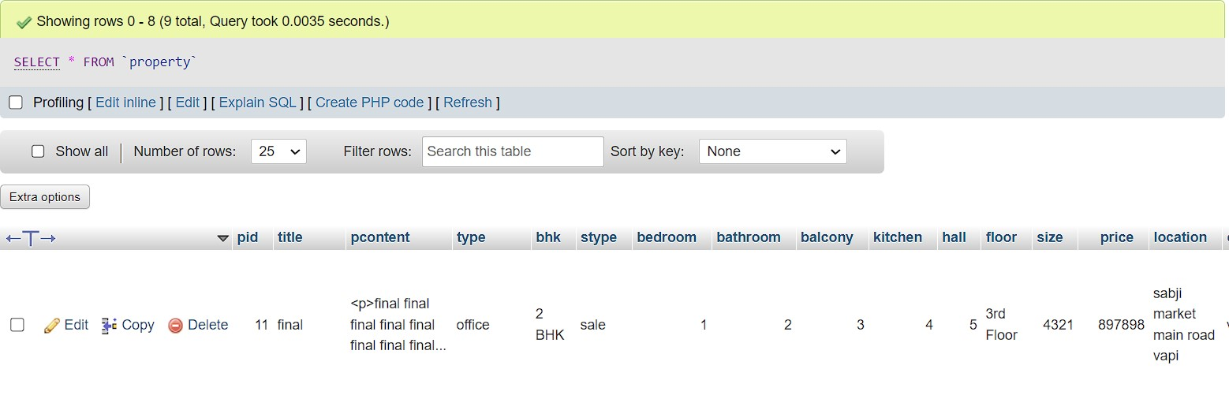

**STATE DATABASE**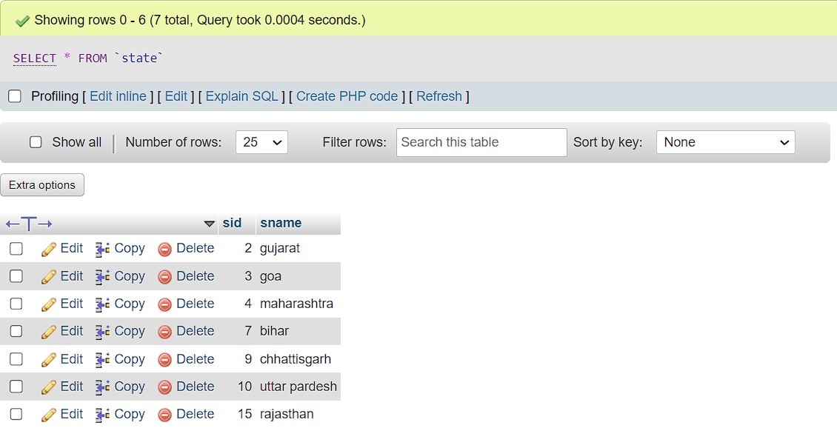

**USER DATABASE**

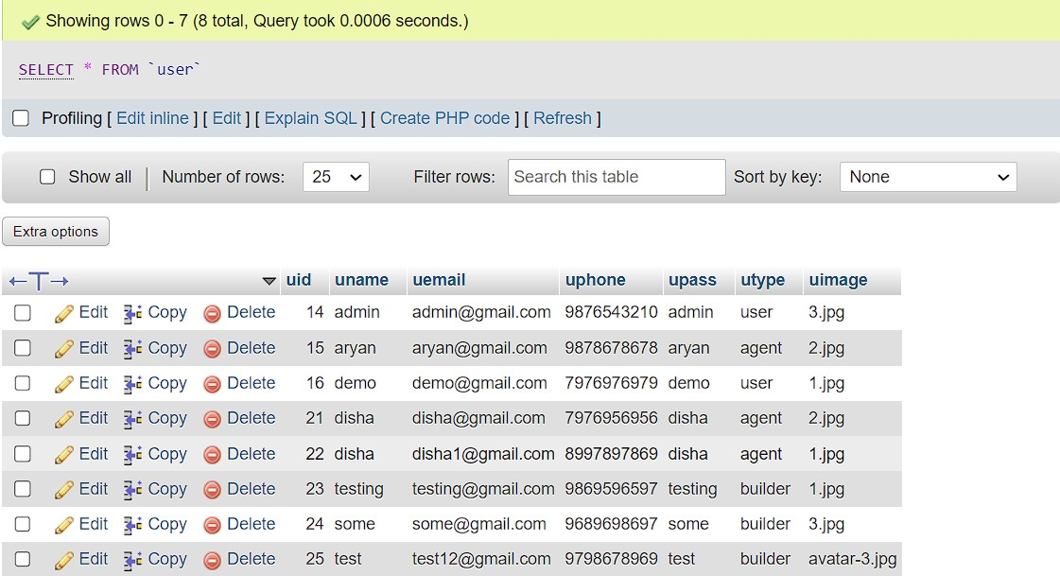

**SCREEN SHORTS**

1.

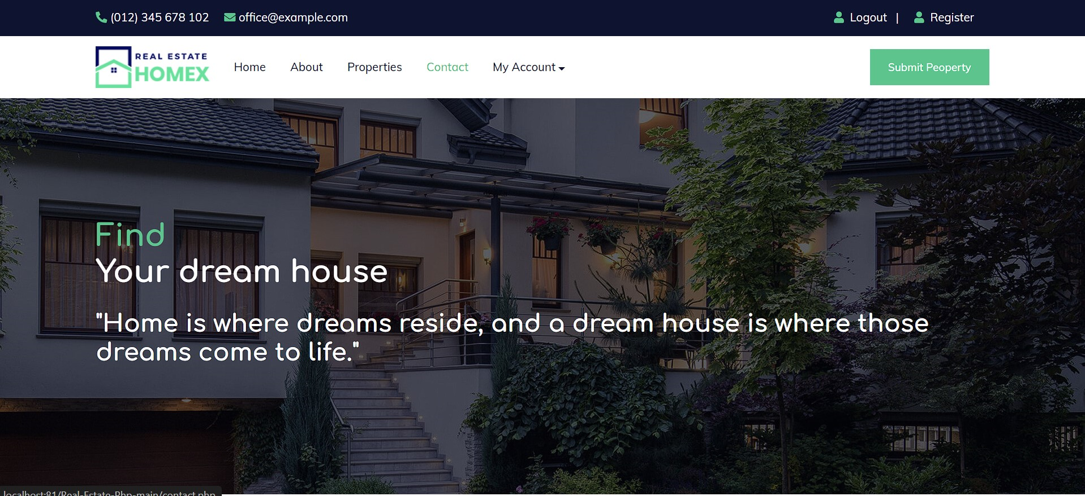

2.



3.

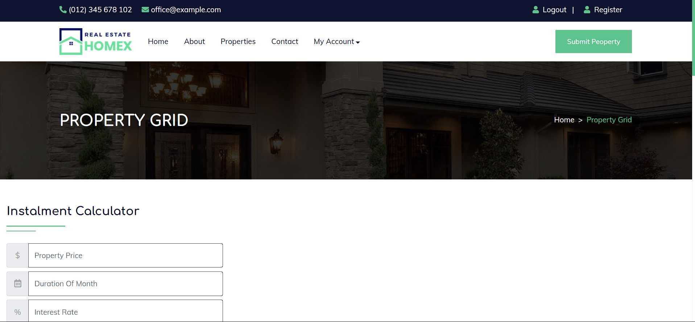

4.

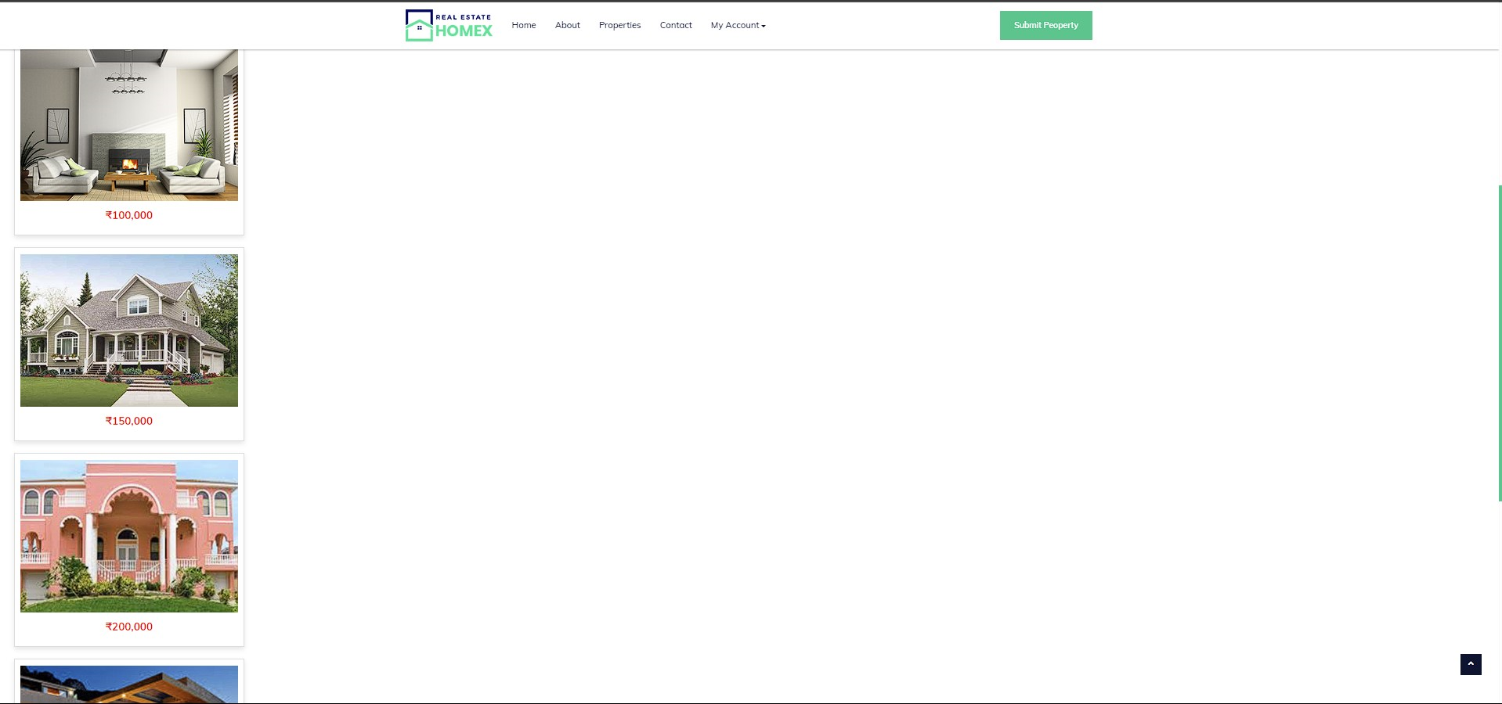

5.

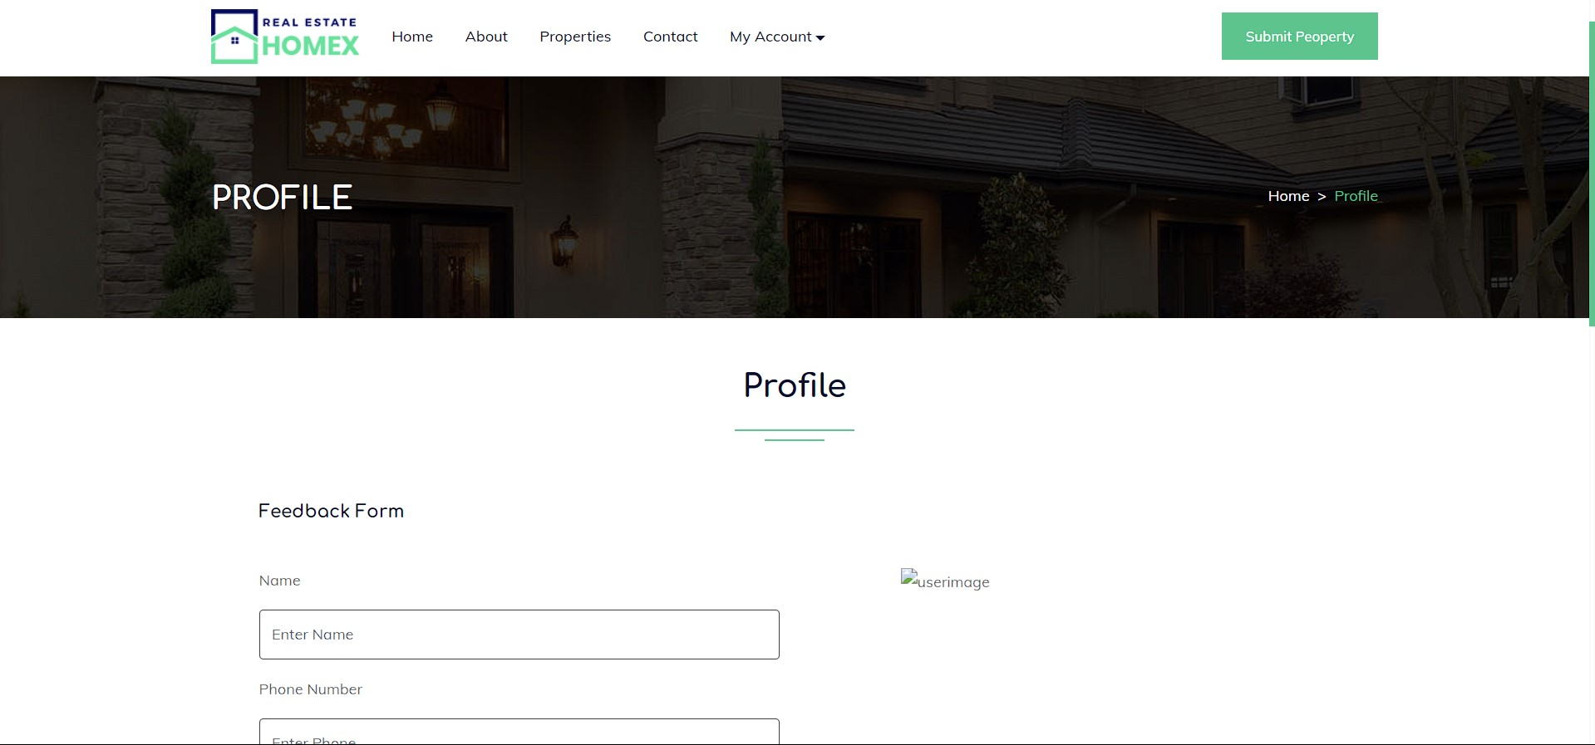

6.

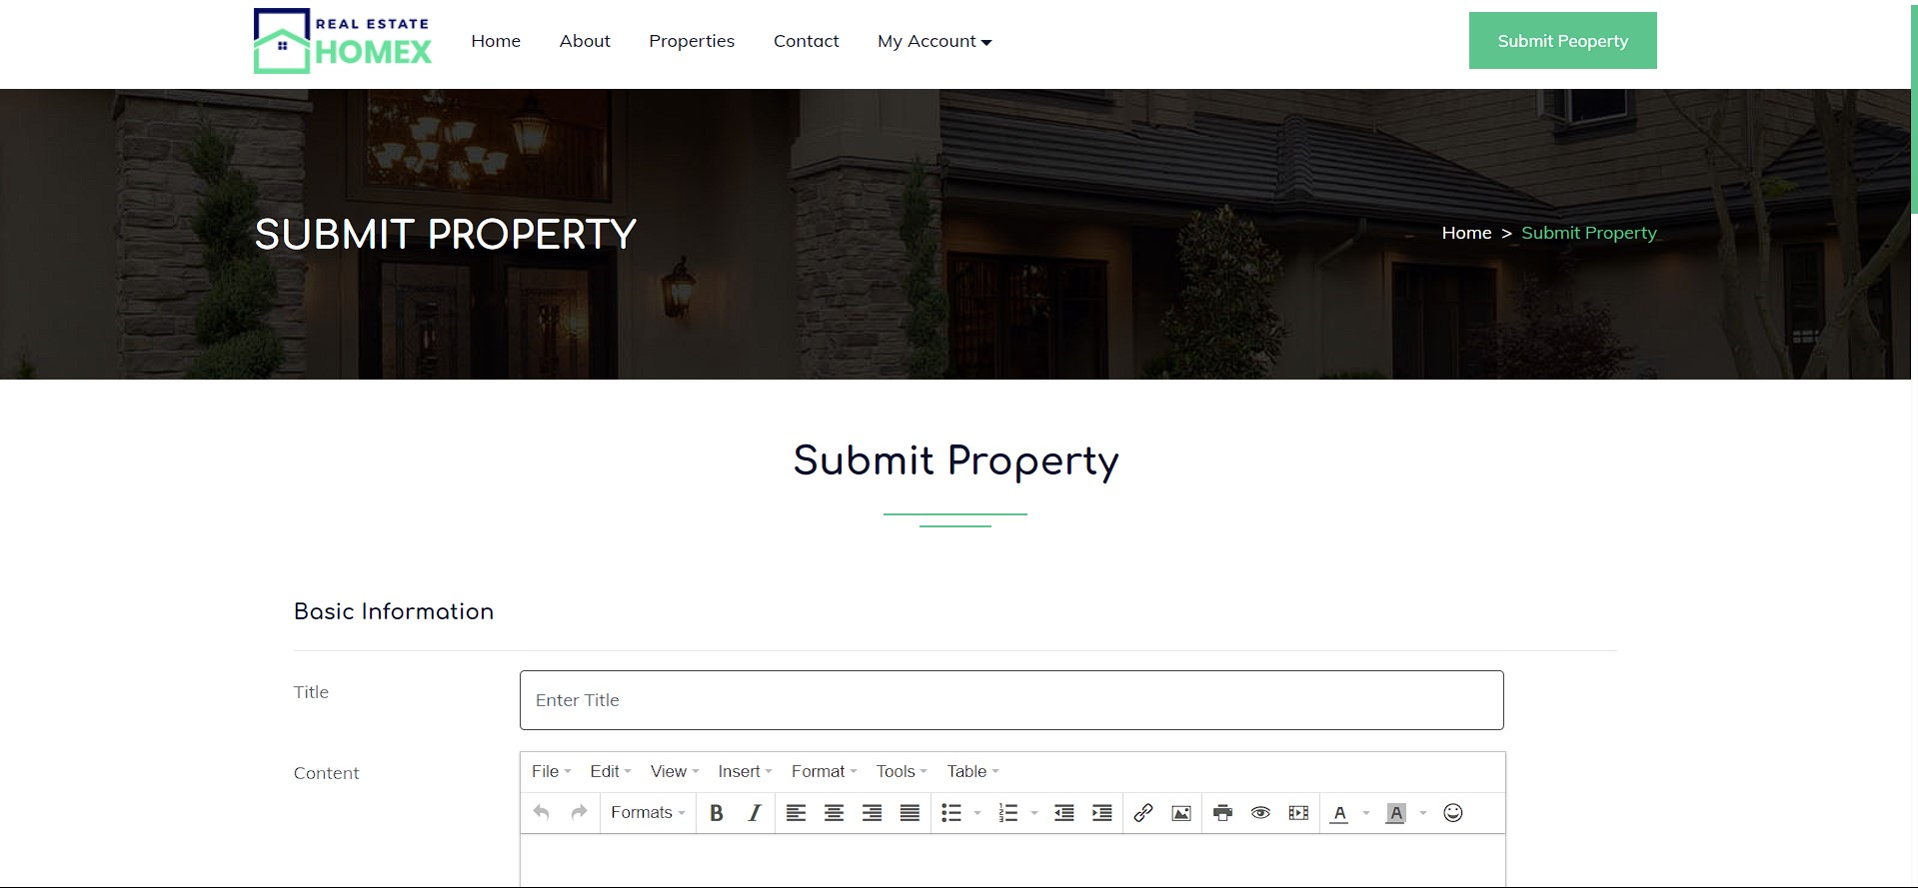

7.

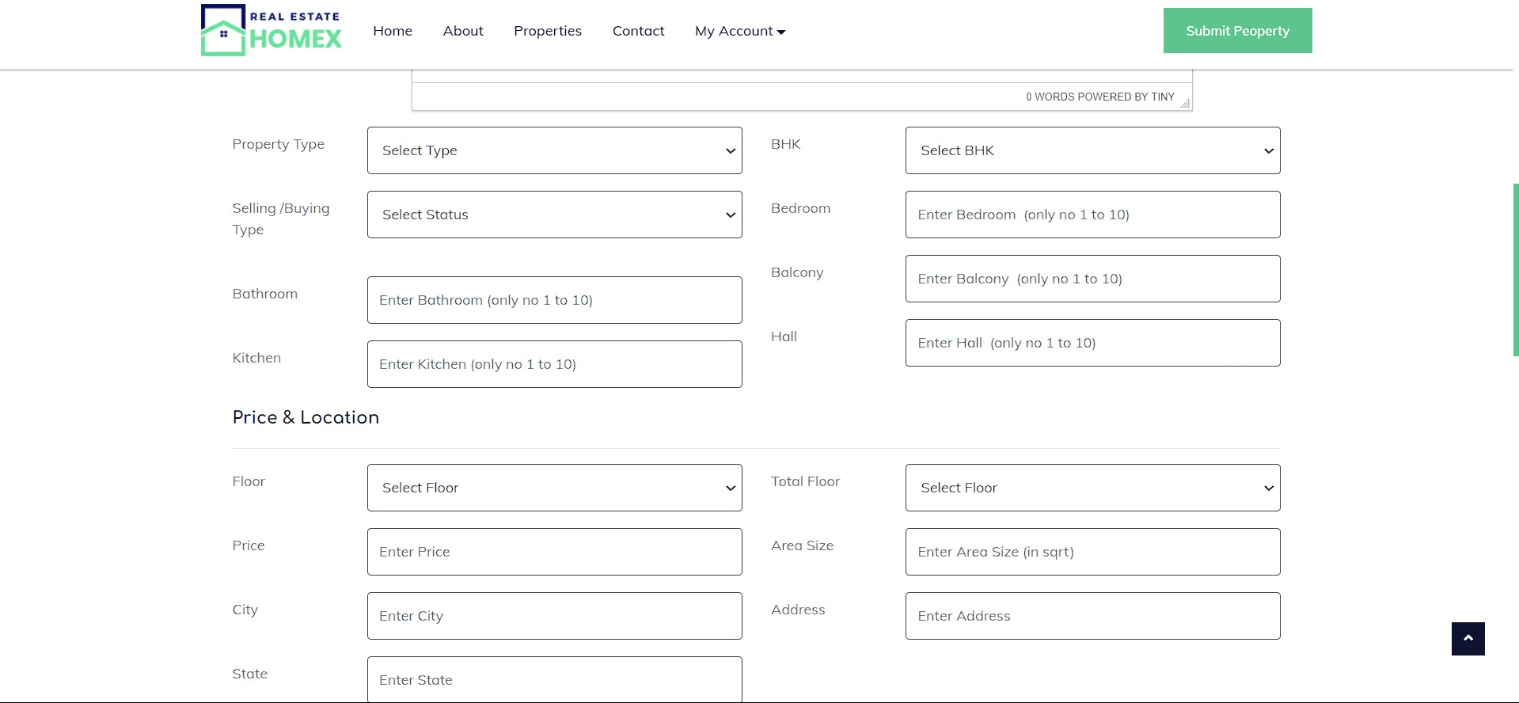

8.

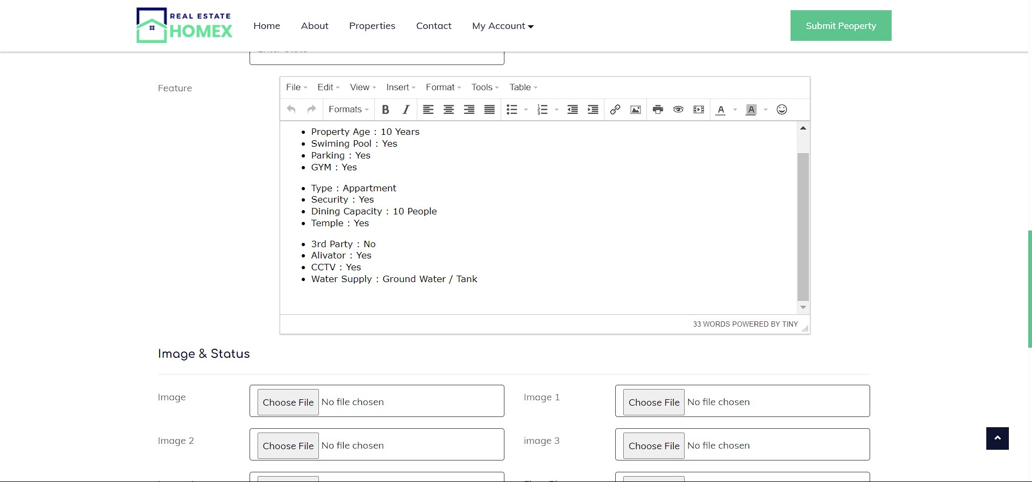

9. 